VALE LEE MURRELL

President’s Message
February 2026


Every month I have relied heavily on members feeding me fodder to write my President’s messages and this month nothing had landed on my lap, that is until I received the extremely sad news that our Lee Murrell had passed

The Probus Club of Seaforth

N E W S L E T T E R
February 2026
Volume 35 Issue 12
Published monthly Private and confidential
For Probus use only — not to be used for any other purpose

February Meeting
Tuesday 24th
Seaforth Bowling Club

Meeting Agenda
9.30 Registration, morning tea and fellowship.
10.00 Guest Speaker: Ian Thompson
— Introduction to Entomology.
10.50 Business.

If not attending, please inform:
Peta Cass, petahcass@gmail.com.

March meeting: Tuesday 24th
away.
While on the one hand it was just too sad for words, on the other hand Lee was such a tremendous role model that he deserves lots and lots and lots of words. He was extra special.
It didn’t matter who you were Lee treated everyone the same with kindness and caring and genuine interest and readily introduced himself and
chatted to newcomers.
You would always hear Lee's whistle before you saw him coming.
Lee joined Seaforth Probus in 2006 and ran our Lawn Bowls activity for 131/2 years from 2010 to 2023 in a very friendly, competent and complete manner, handing over the reins at age 92.
Another example of his stickability, Lee joined Manly Golf Club 72 years ago and was their longest member. That honour is now held by our Anne Eastes, who recently celebrated her 97th and who joined Manly Golf Club just two months after Lee. Now ain’t that pretty special!
The following story sums up the ever thoughtful LEE to a TEE.
Three or four years ago he visited a dentist in the old Balgowlah Post Office building in Sydney Road for the first time and noticed the dentists brass name plaque was looking a tad shabby.
Early next morning he walked over with his Brasso and polishing cloth to do his good deed and polish it up. After one full swipe with his polishing cloth he got a shock to see the letters had come off onto his cloth.
Details of the aftermath of Lee's “good deed that brought him unstuck” are hazy but I do recall him offering to replace the plaque with a brand new one, to which the dentist declined.
Yes, it is fair to say Lee was mightily embarrassed but his good intentions
still shone through.
Lee was a great exponent of the three Fs — FUN, FRIENDSHIP AND FELLOWSHIP.
Imagine for just a moment how much happier the world would be if there were lots and lots more Lee Murrells in it. IF ONLY!
R.I.P. Lee we are very thankful that we shared many happy times with you.
Our sympathies to Little Jan, Looloo, Jenn and Rob and your beautiful
offspring.
And finally this is the third and final call for a Secretary, Vice President and Tour Coordinator for the coming year, nominations to our Secretary immediately.

Nine Seaforth Probians attended Lee Murrell's farewell at Manly Golf Club on Monday, 9th February, 2026 at 2pm.
A very large gathering enjoyed eulogies by his children Looloo, Jenn and Rob; musical tribute and vocals by grandsons Danny Boy on guitar and Brad on trumpet … which on conclusion they almost ‘brought the house down’; stories from three of his grandchildren; photo memories and amusing reflections from two long-term friends.
It was a very fitting farewell to such a treasured and admired friend to many.
Seaforth Probus Club is richer for his 20 year membership with us.
Hazel Sellin, President

Probus Club of Seaforth Newsletter, February 2026
Current Membership 74

Coming Events, Registrations and Payments 2026
Mar 11-18 (Wed-Wed) — Great Ocean Rd and Goldfields Explorer.
July 27-28 (Mon-Tues) — Bathurst and Abercrombie Winter Yulefest Tour.
Credit card, cash or cheque payable to the Probus Club of Seaforth Inc
Seaforth Banking information: BSB — 032 294; Account No. — 690735

Guest Speaker

Ian Thompson — Introduction to Entomology
Ian will introduce us to the fascinating world of insects and other arthropods found in and around the home and garden, including some unusual facts surrounding these critters.

Dianne Swan, Susan Stead

members attended the wake for Lee. Sue Goldberg has had a preventative shingles injection. Nola Davies is recovering from a Carpal Tunnel op. To those of you who have medical appointments, hoping you have good reports, and are able to join us at the next meeting.
Judith Doig

Welfare Report
FEBRUARY BIRTHDAYS
Debbie Gibson 1; Helen Smith 15; Douglas Creek, Jenny Grant 17; John Hodges 22.
I am sure you will have read the email from our President, regarding the passing of Lee Murrell, a fellow member of Seaforth Probus for 20 years. A number of

Activities

SAVE THE DAY

Monthly Luncheon/Quick Quiz
Monthly Luncheon at Tasting Deck, Forestway Markets, 12 noon, Wednesday, March 4.
Names to Carmen Anderson mobile 0422 412 184 or carmen.anderson7@icloud.com
and specify Tasting Deck Luncheon

Carmen Anderson, Hazel Sellin
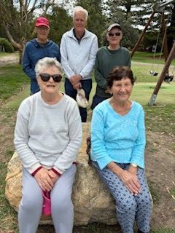
Our February Walkers Dianne and Gary Swan, Reg and Anne Green, with your editor top left — photo Hazel Sellin.
Bowls Report
Welcome back to the greens to John and Jenny Grant … apart from the boost to numbers it’s great to have your company.
Both the dry weather and quorums have been in our favour in the new year, though maybe not the heat, so things are finally looking up.
Hazel Sellin, Bowls Coordinator

Walking Group

Manly to Shelly Beach
Monday, March 2
Walk Details: We meet at 9:30 for 9:45 at the seaside end of the Manly Corso. We will stroll south along the seashore above the rocks past Fairy Bower to Shelley Beach and up to the lookout over Blue Fish Point, then retrace our steps to Bower Cafe for our traditional coffee.
Walk time — Just under one hour.
Grade –— Easy, mostly on flat ground with the path being paved all the way.
Facilities — There are facilities and many seats with sea views along the way.
Parking — 4 hours parking along the beach front for Northern Beaches Residents.
Enquiries — Ray Isaacs, 0478 577 009; Hazel Sellin,
0422 524 021.

Tech Group
The next Tech Group meeting will be at the Totem Club at 11 am April 14.
Members, interested in learning the ins and outs of their mobile phones, iPads and/or laptops, the vagaries of the Internet, spam and AI, etc, are more than welcome. It’s not all serious — plenty of laughs ensured.
If you would like to join our Tech Group, contact Gavin Kerr at ghmkerr@icloud.com or phone 0404 073 760.

2


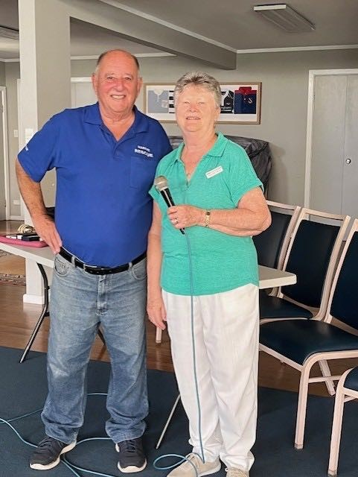
Probus Club of Seaforth Newsletter, February 2026

CoffiīMg EuЯML
Expression of Interest as tour involves interstate return airfares. Refer Clive Sergent sergentc2014@outlook.com or 0412 611 811

Great Ocean Rd and Goldfields Explorer
11 March-18 March 2026
Travel with OnCourse Tours & Travel flying to Melbourne and return to Sydney. Home pick up provided. Tour details attached.
In summary fly to Melbourne with one night in waterfront town of Geelong.
Day 2 travel the Great Ocean Rd to Lorne, Apollo Bay and Twelve Apostles. Staying at the coastal town of Warrnambool for three nights.
On day 5 we travel to Ballarat for two nights. We visit Sovereign Hill and a guided tour of the town.
Departing Ballarat on day 7 we visit Daylesford and on to Melbourne. A river cruise in Melbourne and a visit to the MCG.
Home bound on day 8.

Right: January Guest Speaker Joseph Bataglia; and below: Woy Woy trip riding the Metro — Dianne, Gary and Susan.

3

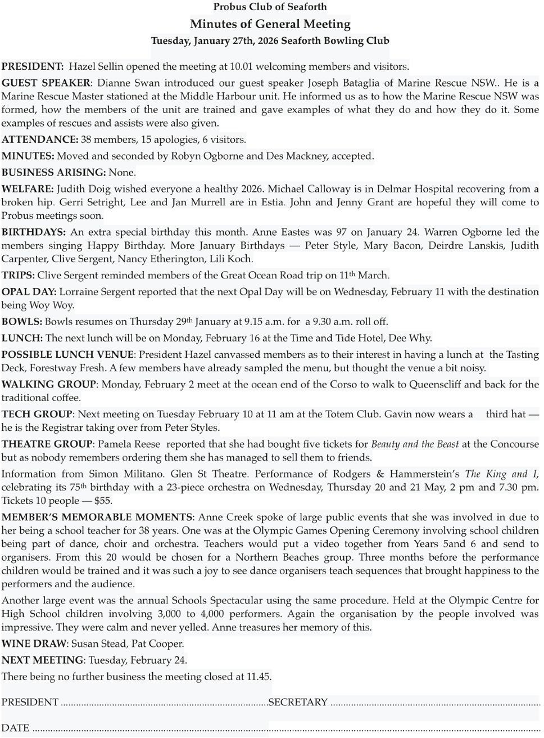
Probus Club of Seaforth Newsletter, February 2026

Probus Club of Seaforth — Founded in 1990, Inc 1996 PO Box 339, Seaforth, 2092 https://SeaforthProbus.Wordpress.com
President: Hazel Sellin 0422 524 021 hazelsellin@bigpond.com; Vice-President: Anne Creek douglas.creek@optusnet.com.au; Secretary: Barbara Mackney 0409 200 279 mackn@bigpond.com; Treasurer: Michael Calloway 0403 207 321 angle_street@optusnet.com.au; Editor and distributor: Ray Isaacs 0478 577 009 ray.n.net@hotmail.com; Getaways Coordinator: Clive SergentDay sergent2014@outlook.con; $2.50 Opal Days: Lorraine Sergent 0410 184 895; Guest Speaker Coordinators: Dianne Swan 0409 837 753 dingary44@gmail.com; Susan Stead 0403 219 849 sstead9@tpg.com.au;
Attendance Registrar: Peta Cass 0419 442 198 petahcass@gmail.com; Welfare Coordinator: Judith Doig 9949 2071 pdoi5805@bigpond.net.au;
Bowls Coordinator: Hazel Sellin 0422 524 021 hazelsellin@bigpond.com; Culture Coordinator: Pamela Reese 9949 2847 pamelareese15@gmail.com;
Walking Group Coordinators: Ray Isaacs 0478 577 009 ray.n.net@hotmail.com; Hazel Sellin 0422 524 021 hazelsellin@bigpond.com;
Luncheon Group Coordinators: Hazel Sellin 0422 524 021 hazelsellin@bigpond.com; Carmen Anderson 0422 412 184 carmen.anderson7@icloud.com; Technology Group/Club Historian/Registrar: Gavin Kerr, 0404 073 760 ghmkerr@icloud.com; Recruiting: Lili Koch 0417 691 779 lilikoch@bigpond.net.au; Pamela Reese 9949 2847 pamelareese15@gmail.com.

4




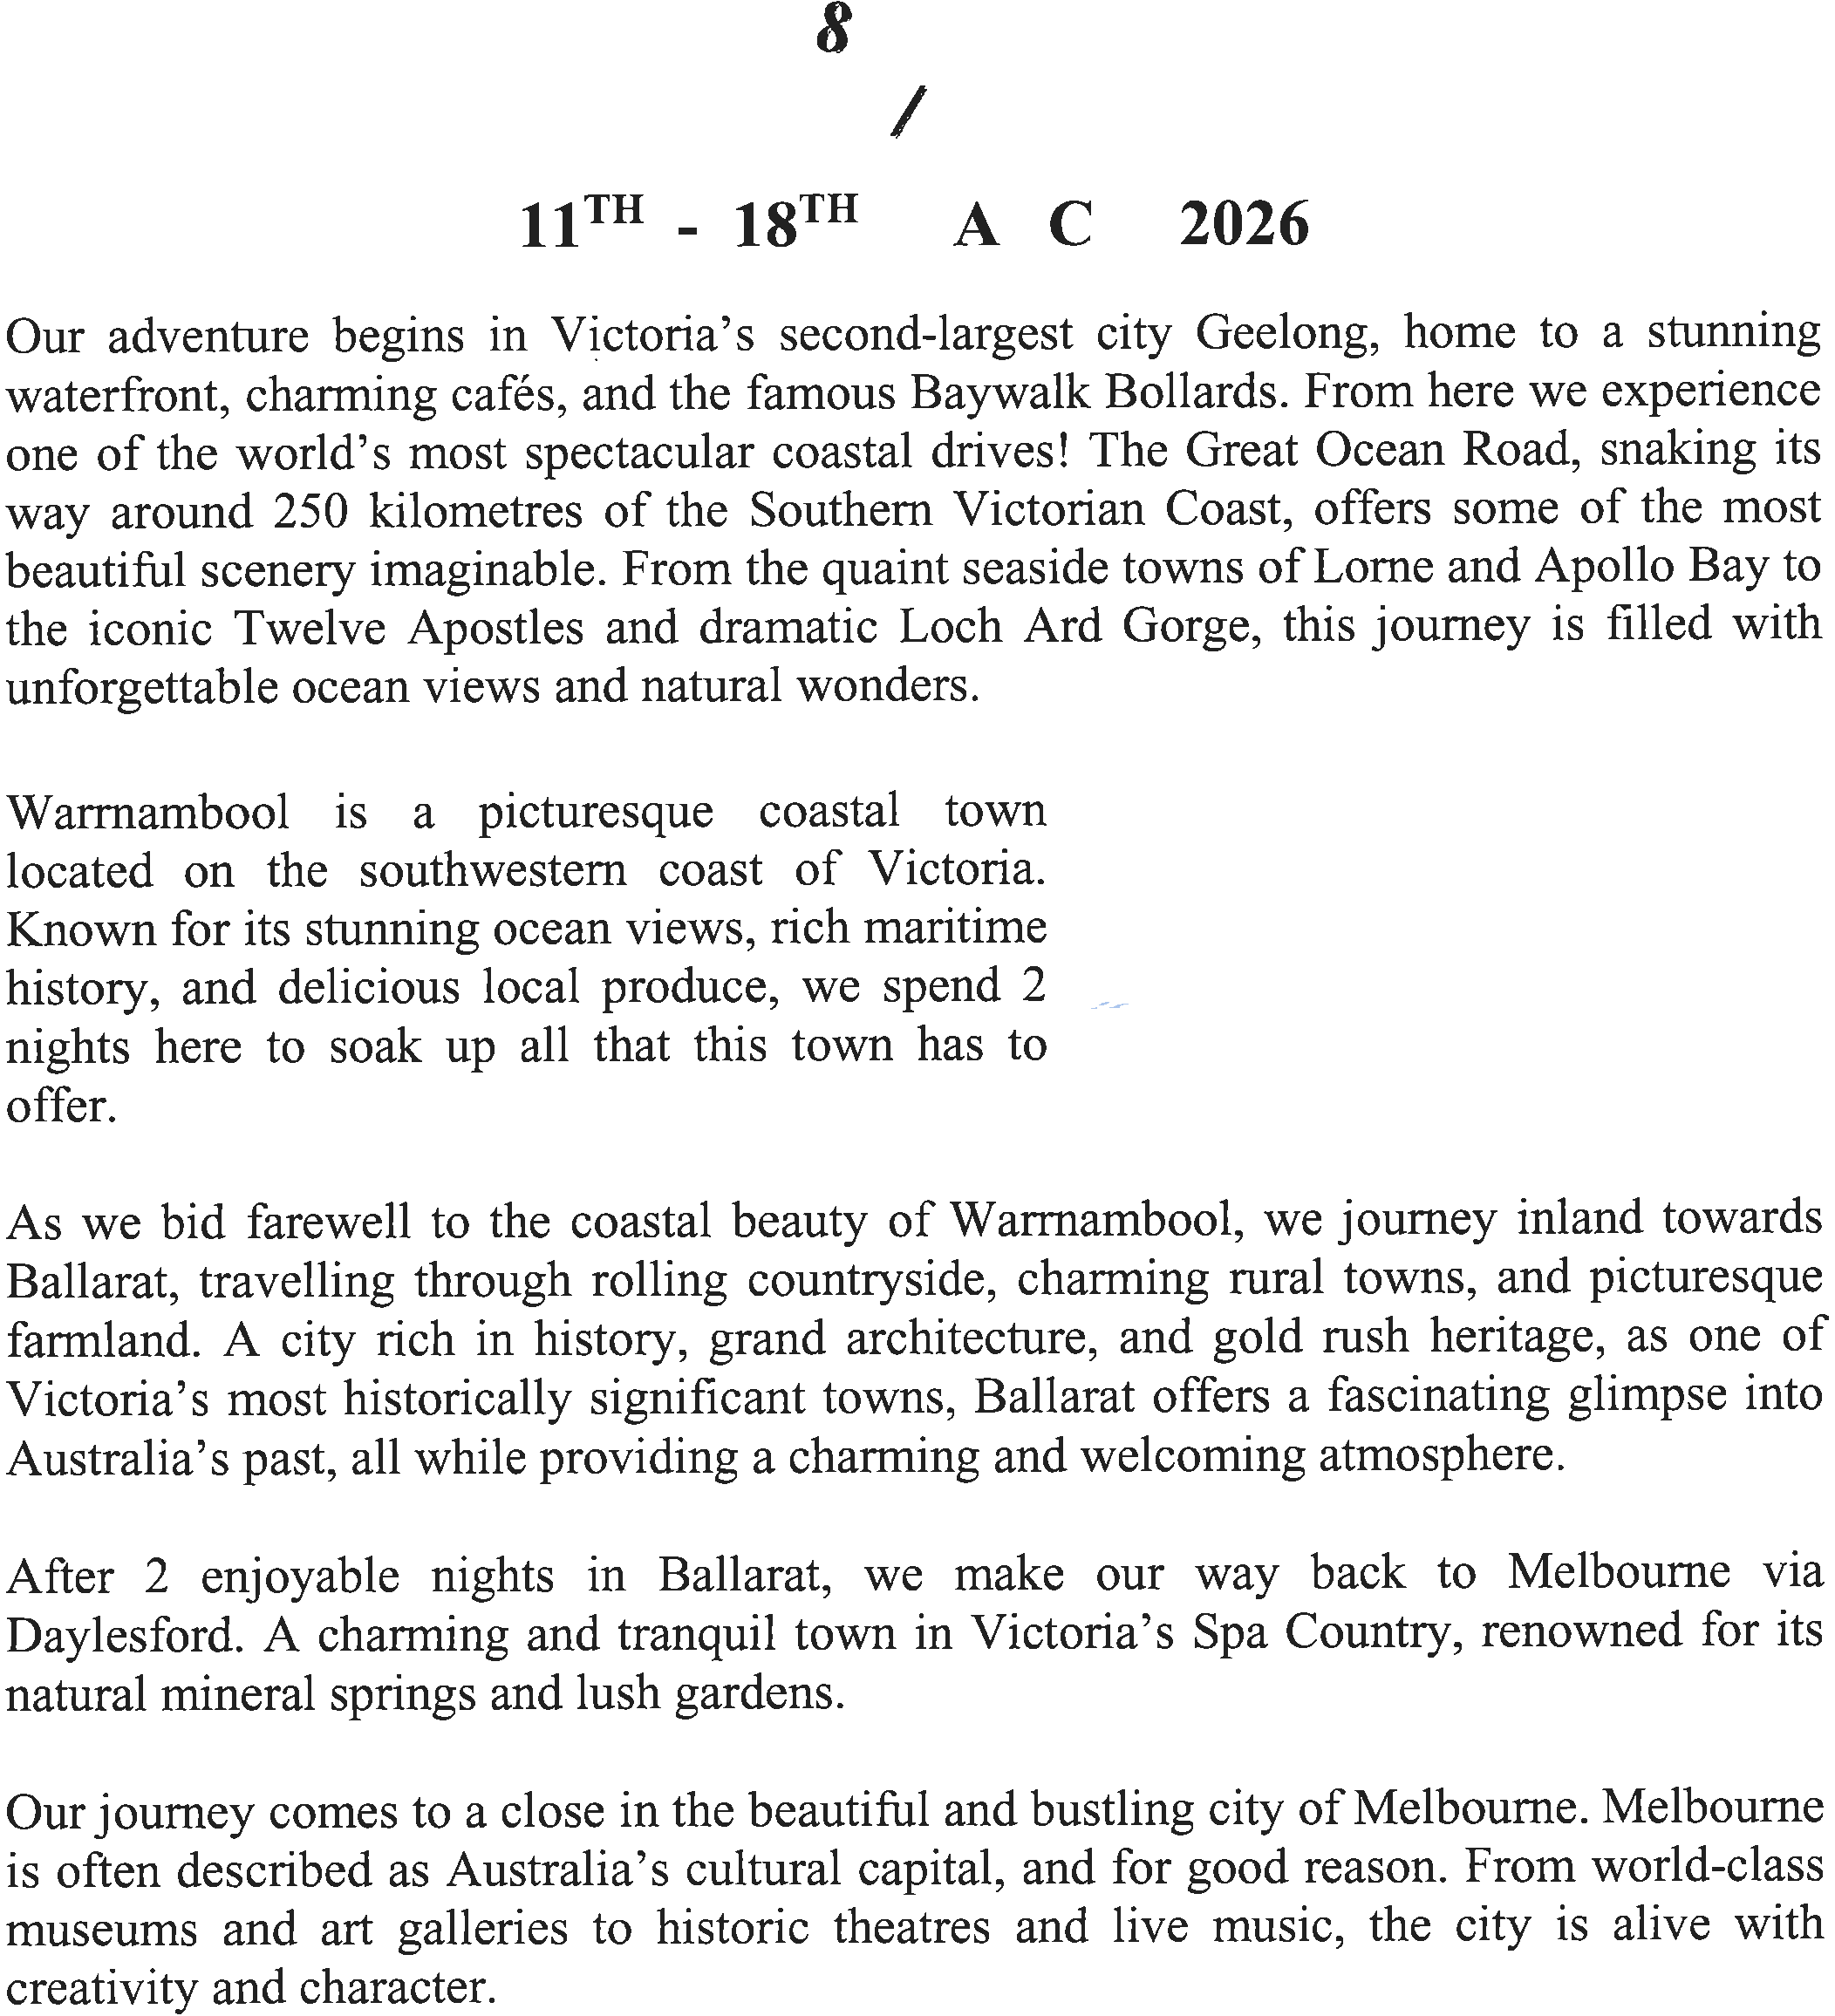



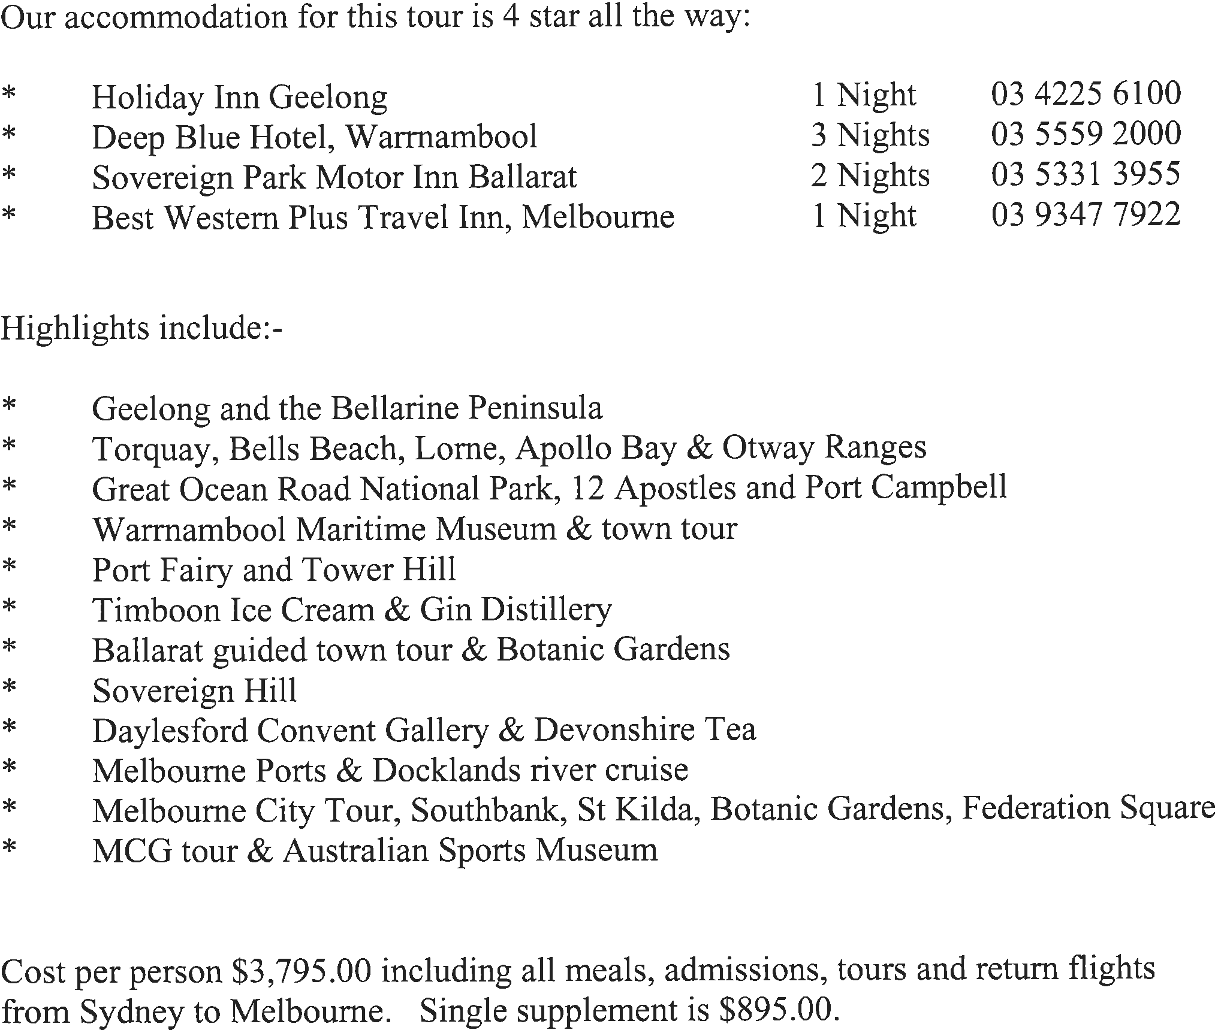

Motion 1
Proposed changes to Constitution and Standing Resolutions
To be proposed at 2026 AGM

Mover: Raymond Isaacs Seconder: Colin Carpenter
This meeting endorse the motion, passed at the general meeting held prior to our Annual General Meeting held on March 25 2025, that our membership Annual Fee be increased to $90 — covering the annual membership fee and the monthly attendance fee.

The reason for this motion is that the Constitution states that changes to annual fees must be passed at an Annual General Meeting. The Standing Resolutions requires any change needs to be passed by a general meeting; this being inconsistent with the Constitution, thus the motion to change the annual fees which was moved and passed at the March 25 meeting prior to the AGM needs to be endorsed by this AGM.

Motion 2
Mover: Raymond Isaacs Seconder: Colin Carpenter
- Standing Resolution 17-1 be amended to read “at a General Meeting.”
- Standing Resolution 17-1 Paragraphs (b) and (c) be deleted. The remaining paragraphs be renumbered as appropriate.

Paragraph 1. Is merely a “grammatical” correction.
Paragraph 2. Both paragraphs (b) and (c) are inconsistent with Section 7(c) of the Constitution and are not needed and, as such, meaningless. They should be deleted to prevent any confusion.

Motion 3
Mover: Raymond Isaacs Seconder: Colin Carpenter
Insert in the Constitution, Section 8 — Finance, after subparagraph (e) Cheques in payment of accounts shall be signed by authorised signatories who shall be any two of the President, Vice President or Secretary;
  - Payment by electronic means may be made by:
    - The Treasurer;
    - In the absence of the Treasurer, the President or Secretary.

Straight forward — with the advent of electronic banking there is a need to amend the Constitution to cover the new process of electronic withdrawals.

