President’s Message

May 2026
As everyone says technology is wonderful when it works! We experienced a glitch at our last meeting and despite the best efforts of many people we had to cancel the talk and display. A great pity as the topic sounded very interesting. Hopefully it can be rebooked.
Thank you to all those who tried to assist.
I hope all our wonderful mums enjoyed their special day last Sunday and were able to celebrate with some family members. It was a glorious day. We decided on a gourmet picnic at Clontarf. We were given some delicious food by a lovely Lebanese family who were visiting from Blacktown. Really delicious food.
I'm not sure if members are aware but as of 15/5/26 RSV injections are available at no cost to many older people. I'm not sure of the minimum age.
It seems to be a good idea.
If possible I'd like to introduce a short talk by all members of a favourite/ exciting/memorable holiday. I'll be asking for names at the meeting.
Please be part of this little segment.
Looking forward to meeting more members at our next meeting.

Anne Creek

Guest Speaker
Susan Ackroyd — English History through Nursery Rhyme
Our guest speaker for May is Susan Ackroyd, her topic is English History through Nursery Rhymes.
Susan is the author of Rhyme and Reason an English History through Nursery Rhymes. You will gain an understanding of History from medieval times through to the 1700s through rhymes and their stories. Parents, grandparents and teachers will find the origin of these rhymes fascinating. She will have copies of her book, Rhyme and Reason available, $30 cash or
card and her website is www.susanackroyd.com

Welfare Report

Dianne Swan, Susan Stead


I am sure you are aware of the next season we are approaching — WINTER — hence we need to be extra careful with our health — colds, flu etc, plus the extra cords laying on the ground with fires and bed blankets, to be turned off before retiring at night, extra thinking. So please be vigilant with this time in looking after your self and family.

The Probus Club of Seaforth

N E W S L E T T E R
May 2026
Volume 36 Issue 3
Published monthly Private and confidential For Probus use only —
not to be used for any other purpose

Meeting Date
Tuesday 26th
Seaforth Bowling Club

Agenda
9.30 Registration, morning tea and fellowship.
10.00 Guest Speaker: Susan Ackroyd
— English History through Nursery Rhyme.
10.50 Business.

If not attending, please inform: Peta Cass, petahcass@gmail.com.

June meeting: Tuesday 23rd
Unfortunately Judy Campbell had a fall in the bathroom and Jenny Grant has a back problem. Look after yourselves and hope to see you next the net meeting.

Judith Doig
Coming Events, Registrations and Payments 2026
June-3 (Wed) — $2.50 Opal Discovery Day — Haberfield Gourmet Village — Manly Wharf
10.15 am for 10.30 ferry.
July 27-28 (Mon-Tues) — Bathurst and Abercrombie Winter Yulefest Tour — contact OnCourse Tours now to book your place — Cost $675 pp.
Credit card, cash or cheque payable to the Probus Club of Seaforth Inc
Seaforth Banking information: BSB — 032 294; Account No. — 690735
MAY BIRTHDAYS
Anne Creek, Margaret Draper, 8; Reg Green, 11; Grahame Goldberg, John Rose, 13; Robyn Ogborne, Dianne Swan, 21; Lorraine Sergent, 29.

Current Membership 75

Activities

Monthly Luncheon/Quick Quiz

12 noon Monday June 15
The June luncheon will be at Club Belrose (Belrose Bowling Club). As per all luncheons, good food, great company and lastly the famous trivia quiz. Do’t miss out.
Carmen Anderson, Ruth Calloway

Bowls Report
With an audience comprising of Pam Fizelle and photographer Hazel, previous winner Reg Green presented the Ric Clapp Trophy to Nola Davies who was victorious in our last competition.
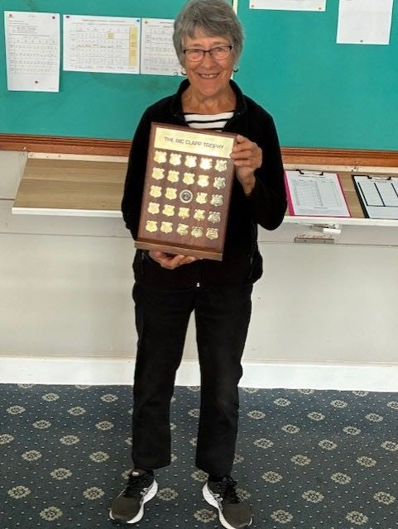
Congratulations Nola!
As we are now down to eight, I reiterate eight players, we have decided to make four our new official quorum.

The good news is we had four bowlers this morning which enabled us to officially complete week one of our new competition.
One might say “we are hanging in by the skin of our teeth”.
REMEMBER THE DRILL — be at Seaforth Bowling Club by 9.15 am Thursday mornings, wearing flat shoes and a smile and have a laugh or two.
Hazel Sellin, Bowls Coordinator

Walking Group

Narrabeen Lakes West

Monday, June 1
Walk Details: We will meet at 9:30 for 9:45 at the Deep Creek Reserve car park next to the road bridge on Wakehurst Parkway at the western end of Narrabeen Lakes and walk around the Deep Creek walkway returning to our cars for a short drive Narrabeen for our traditional coffee.
Walk time — Approximately one hour.
Grade — Medium.
Parking — Free parking.
Enquiries — Ray Isaacs, 0478 577 009; Hazel Sellin,
0422 524 021.

Tech Group
The next Tech Group meeting will be at the Totem Club at 11 am Tuesday, June 9.
Members, interested in learning the ins and outs of their mobile phones, iPads and/or laptops, the vagaries of the Internet, spam and AI, etc, are more than welcome. It’s not all serious — plenty of laughs ensured.
If you would like to join our Tech Group, contact Gavin Kerr at ghmkerr@icloud.com or phone 0404 073 760.

Membership fees now due
All membership fees due May 31.
Your $90 subscription may be paid by electronic funds transfer, BSB 032294 — account 690735, at any time. Credit card, cash of cheques to Michael Calloway at our May 26 meeting.

$2.50 Opal Discovery Day Haberfield Gourmet Village Wednesday, June 3
A village feel with and very much Little Italy. Renowned for authentic Italian deli goods and restaurants, Papa Pasticceria is a stand out and we will lunch there. Special offers on Wednesday include any pizza for $20. Temping pastries and sweets to take home.
Local shopping recommended is the Pasta shop.
Travel Program: Meet at Manly Wharf for a 10.30 am ferry departure. Early birds can get a takeaway coffee at

Max Brenners. At Circular Quay we catch the Light Rail to the QVB stop in George Steet. Follow the Queen Victoria Building to York Street and look for Bus Stand B at the southern end of the QVB.
Catch Bus 437 at 11.35 am for Haberfield shops arriving at 11.58 am (if you wish to meet at the bus stop for the 437 please advise Lorraine Sergent.
Homebound: Depart after 2 pm, catch the same 437 bus outside Papa Passticceria in Ramsay St.

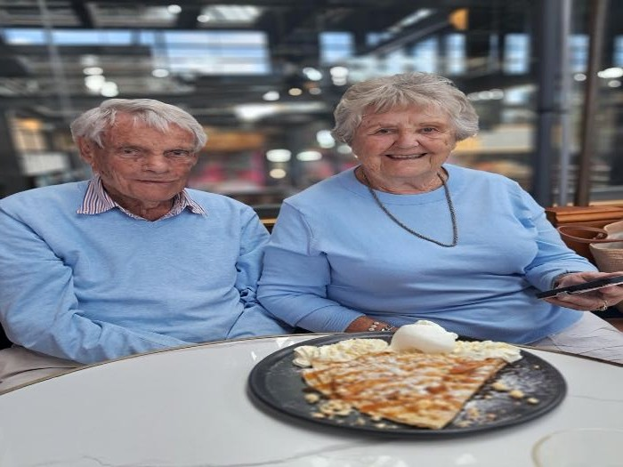
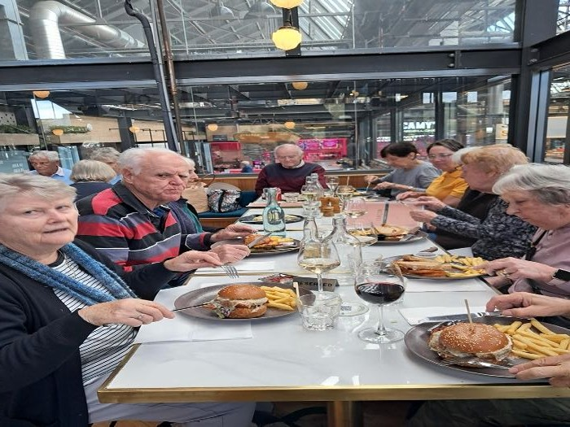
Register with Lorraine Sergent to assist with lunch booking. Either at the May meeting or phone 0410 184 895.

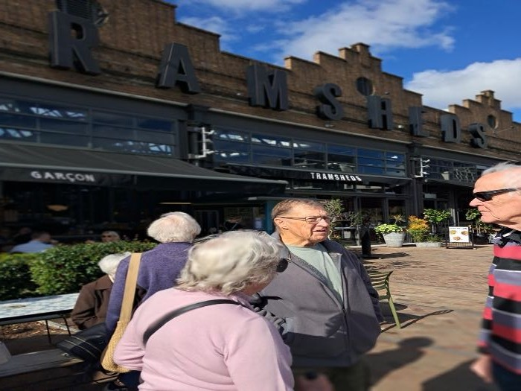
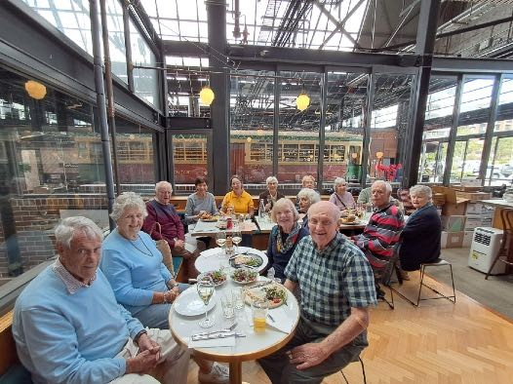
ABOVE: our happy diners at Garçon, The Tramsheds, Forest Lodge.

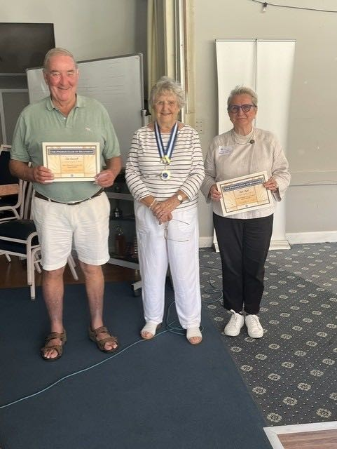
RIGHT: John Kenniwell and Helen Pajak were welcomed
as members by President Anne Creek.

BELOW: Nola receiving the Ric Clapp Trophy from previous winner Reg Green, with Pam Fizella in background.
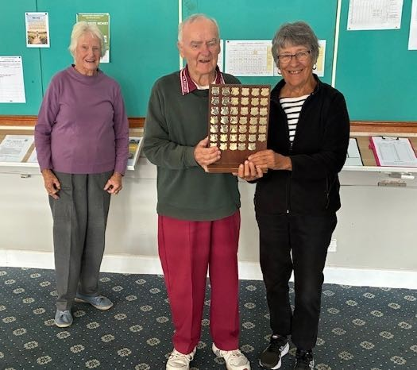

Probus Club of Seaforth — Founded in 1990, Inc 1996 PO Box 339, Seaforth, 2092 https://SeaforthProbus.Wordpress.com
President: Anne Creek 0422 227 499 douglas.creek@optusnet.com.au; Vice-President: vacant; Secretary: Annette Kearns 0417 412 447
amtk1944@hotmail.com; Treasurer: Michael Calloway 0403 207 321 angle_street@optusnet.com.au; Editor and distributor: Ray Isaacs 0478 577 009 ray.n.net@hotmail.com; Getaways Coordinator: vacant; $2.50 Opal Days: Lorraine Sergent 0410 184 895 lsergent44@gmail.com; Guest Speaker Coordinators: Dianne Swan 0409 837 753 dingary44@gmail.com; Susan Stead 0403 219 849 sstead9@tpg.com.au; Attendance Registrar: Peta Cass
0419 442 198 petahcass@gmail.com; Welfare Coordinator: Judith Doig 9949 2071 pdoi5805@bigpond.net.au; Bowls Coordinator: Hazel Sellin 0422 524 021 hazelsellin@bigpond.com; Culture Coordinator: Pamela Reese 9949 2847 pamelareese15@gmail.com; Walking Group Coordinators: Ray Isaacs 0478 577 009 ray.n.net@hotmail.com; Hazel Sellin 0422 524 021 hazelsellin@bigpond.com; Luncheon Group Coordinators: Hazel Sellin 0422
524 021 hazelsellin@bigpond.com; Carmen Anderson 0422 412 184 carmen.anderson7@icloud.com; Technology Group/Club Historian/Registrar:
Gavin Kerr, 0404 073 760 ghmkerr@icloud.com; Recruiting: Lili Koch 0417 691 779 lilikoch@bigpond.net.au.

Probus Club of Seaforth
Minutes of General Meeting
Tuesday 28 April, 2026 –- Seaforth Bowling Club

President opened the meeting at 10.01 welcoming members and visitors.
GUEST SPEAKER: Margaret Haynes, our guest speaker re Good News about Climate Change, due to technical difficulties, was cancelled. A future date to be arranged.
ATTENDANCE: 38 members, 21 apologies, 3 visitors – Helen Pajak, Yvonne Edwards and John Kenniwell.
MINUTES: Moved Maggie Crosby, seconded Lorraine Sergent that March minutes be accepted.

BUSINESS ARISING: Nil.
INDUCTIONS: John Kenniwell and Helen Pajak were welcomed as members by the President.
WELFARE: Judith Doig advised that Mary Bacon has relocated to Perth near her niece. Gavin Kerr is in a moon boot and Barbara Harvey is in hospital with a virus.
TREASURERS REPORT: March expenses $597.10, Income $1070, balance $6,854.31. Our Probus South Pacific fees to come out of that balance. Annual fees due May.
VICE PRESIDENT: Position still vacant and President appealed for someone to fill the position.
BIRTHDAYS: Barbara Harvey, Gera Fussell, Hazel Sellin, Carmen Anderson, Michael Calloway, Helen Gulliford, Gavin Kerr.
OPAL DAY: Lorraine Sergent said trip to Tramshed Glebe was great. Next — Wednesday 3rd June to Haberfield — Italian Restaurant.
TRIPS: President is putting some ideas to committee and bring up at next meeting.
BOWLS: Nola Davies won Thursday bowls.
LUNCH: 20th May at Builders Club, Dee Why at 12 noon. All on menu $26.
WALKING GROUP: Dobroyd Head to North Harbour Reserve on Monday 4th May 9.30 am.
TECH GROUP: Next meeting May 12, Totem Club 11 am.
GENERAL BUSINESS: President advised that she had a few ideas .to put to Committee meeting. Judith Carpenter stated that visitors are called temporary members now. Also wearing badges to and from home covers insurance.
Also how long do records have to be kept. Refer to Gavin Kerr who is responsible for archives. Picnic at Clontarf was a great success.
WINE DRAW: Peta Cass, Clive Sergent.
Because of guest speaker being cancelled various members related their stories.
NEXT MEETING: 26th May, 2026
There being no further business the meeting closed at 10.30 am

President ....................................................................... Secretary .......................................................................

Date...............................................................................

