
President’s Message

The Probus Club of Seaforth

N E W S L E T T E R
June 2026
Volume 36 Issue 4
Published monthly Private and confidential
For Probus use only — not to be used for any other purpose

June Meeting
Tuesday 23rd
Seaforth Bowling Club

Meeting Agenda
9.30 Registration, morning tea and fellowship.
10.00 Guest Speaker: Commodore Christopher "Kit" Rynd — Command of Cunard's QE2 and Queen Mary 2.
10.50 Business.

If not attending, please inform: Peta Cass, petahcass@gmail.com.

July meeting: Tuesday 28th

June 2026
Well, I hope the start of winter hasn't been too difficult for our members. The only consolation is that it's only a few days to the 21st of June, the shortest day.
Personally, i can't wait for winter to be over.
Wasn't it a joy , listening to our last speaker? Who would have known so many of our nursery rhymes were associated with historical events. I could have listened to her for much longer. Some people are so interesting when they are talking to the subject they love.
It was pleasing to welcome three visitors to our last meeting. Do try and pass on the message of how much Seaforth Probus has to offer.
Thank you Hazel and Susan for attending the Probus Information Day at Cromer. Hazel will be able to tell us of some of the suggestions discussed. Hazel is also going to talk of her wonderful trip to Lake Eyre , hopefully in August , when she will show us some photos.
Another successful $2.50 outing was arranged by Lorraine and Clive. The Italian cafe had delicious food and great atmosphere. Doug and I drove around Haberfield admiring the many lovely old stone houses and other buildings.
Thanks to Judith for rearranging the date for our Christmas in July (now August) lunch. Very well organised.
Please feel free to make suggestions for different activities during our meetings — all suggestions are welcome. Variety makes the meetings better for everyone, I am sure many of you have some great ideas.

Looking forward to seeing you at our next meeting,
Anne Creek
Xmas in August
Tuesday, August 25
following our monthly meeting, 12.30 pm for a sit down meal.
Two courses $55; Champagne/orange juice on arrival.
When paying please indicate any dietary problems
and indicate with whom you may wish to sit.
Tables of 6.
Payment by cash, cheque or direct debit EFT 032-294, Acc 690-735.
JUNE BIRTHDAYS
David Gibbs 2; Mary Smart 5; Stan Gibson 25.
Current Membership 74

Coming Events, Registrations and Payments
2026
July 27-28 (Mon-Tues) — Bathurst and Abercrombie Winter Yulefest Tour — contact OnCourse Tours now to book your place — Cost
$675 pp.
Aug 19 (Wed) — $2.50 Opal Day — Westmead Research Centre. Aug 25 (Tues) — Xmas in August — 12.30 following July meeting,
SBC — Cost 55 pp.
Oct 21 (Wed) — $2.50 Opal Day — Details to follow.
Credit card, cash or cheque payable to the Probus Club of
Seaforth Inc
Seaforth Banking information: BSB — 032 294; Account
No. — 690735

Guest Speaker
Commodore Christopher "Kit" Rynd
The guest speaker for June is Retired Commodore Christopher "Kit" Rynd.
Topic: Command of Cunard's QE2 and Queen Mary 2 Christopher spent 48 years at sea, the majority in
passenger and cruise ships on world wide itineraries including eight years as a list 1 Reserve Officer in the British Navy.
When he retired from his full time seagoing career he took on numerous rolls within the Nautical Institute of SE Australia Branch, a professional standards organisation. He has a life long interest in maritime history and navigation with significant experience in SE Asia and the Pacific.

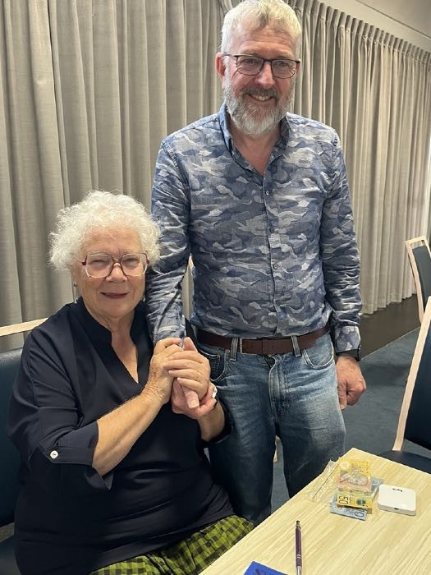
May Guest speaker Susan Ackroyd and husband.

Welfare Report

Dianne Swan, Susan Stead
any news of members. If you are undergoing medical treatment, hoping for good results. Hopefully see you at the next Probus meeting.

I think we all know what season we are enduring, may
be even hibernating for a short time. Have not received
Activities
Monthy Luncheon/Quick Quiz
SAVE THE DAY
Wednesday, July 22, 2026.
12 noon, venue to be advised.
Carmen Anderson and Hazel Sellin
Regards …

Walk time — 45 minutes.

Judith Doig

Bowls Report
Same old story again this month … dwindling numbers
and but amazingly on the 4th June the sun shone brightly and four bowlers thoroughly enjoyed a highly contested game, which resulted in a draw.
Oh! for a few more sunny Thursday mornings.
Hazel Sellin, Bowls Co-ordinator

Walking Group

Mounties to Curl Curl Beach

Monday, July 6
Walk Details: We meet at 9:30 for 9:45, near the flag pole in the outside car park next to Mounties Freshwater (Harbord Diggers). We will stroll north along the boardwalk down to Curl Curl Beach, then back up to the Mounties Club coffee bar for our traditional coffee.
Grade — Moderate, mostly on boardwalk to beach — some steps at top.
Facilities — There are facilities at Mounties and at Curl Curl Beach as well as some seats to watch the waves roll in along the way.
Parking — Free parking.
Enquiries — Ray Isaacs, 0478 577 009; Hazel Sellin,
0422 524 021.

Tech Group
The next Tech Group meeting will be at the Totem Club at 11 am Tuesday, July 14.
Members, interested in learning the ins and outs of their mobile phones, iPads and/or laptops, the vagaries of the Internet, spam and AI, etc, are more than welcome. It’s not all serious — plenty of laughs ensured.
If you would like to join our Tech Group, contact Gavin Kerr at ghmkerr@icloud.com or phone 0404 073 760.

$2.50 Opal Discovery Day Children’s Medical Research Centre Westmead (CMRI)
Wednesday, August 19, 10 am to 2 pm — see attachment

Cost $25 includes Devonshire Tea and light lunch
Travel Program: Meet at Wynyard Station Platform 3, 8.45 am for the T1 Penrith train 8.52 am to Westmead Station. Look for our group near the rear steps. At Westmead Railway Station 9.30 am exit for the Westmead Light Rail L4 Carlingford. Travel two stops to the Children’s Hospital to arrive at 9.40 am. Walk 100m to CMRI, 215 Hawkesbury Road, Westmead.
Any route changes to CMRI after a dry run early July will be advised in the July Newsletter.
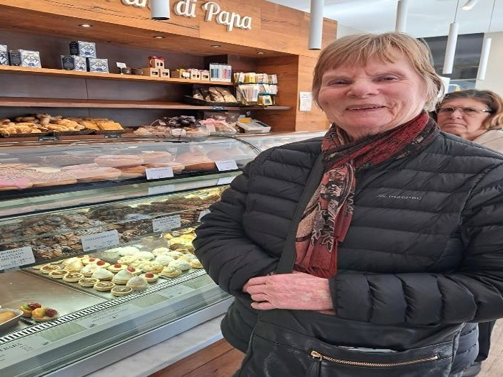
Register with Lorraine Sergent (not attending June meeting) on 0410 184 895 or lsergent44@gmail.com. We have 20 places. Please confirm your booking with Lorraine and after pay $25pp to Seaforth Probus bank account BSB 032 294 Account 690 735.

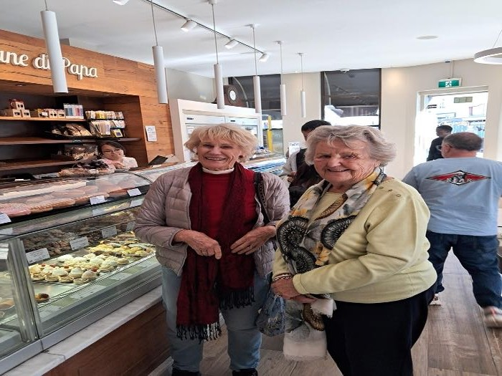

PHOTOS THIS PAGE: Three Presidents — two ex-
and current President — Helen Gulliford, Hazel Sellin and Anne Creek, checking out dessert.

Probus Club of Seaforth — Founded in 1990, Inc 1996 PO Box 339, Seaforth, 2092 https://SeaforthProbus.Wordpress.com
President: Anne Creek 0422 227 499 douglas.creek@optusnet.com.au; Vice-President: vacant; Secretary: Annette Kearns 0417 412 447
amtk1944@hotmail.com; Treasurer: Michael Calloway 0403 207 321 angle_street@optusnet.com.au; Editor and distributor: Ray Isaacs 0478 577 009 ray.n.net@hotmail.com; Getaways Coordinator: vacant; $2.50 Opal Days: Lorraine Sergent 0410 184 895 lsergent44@gmail.com; Guest Speaker Coordinators: Dianne Swan 0409 837 753 dingary44@gmail.com; Susan Stead 0403 219 849 sstead9@tpg.com.au; Attendance Registrar: Peta Cass
0419 442 198 petahcass@gmail.com; Welfare Coordinator: Judith Doig 9949 2071 pdoi5805@bigpond.net.au; Bowls Coordinator: Hazel Sellin 0422
524 021 hazelsellin@bigpond.com; Culture Coordinator: vacant; Walking Group Coordinators: Ray Isaacs 0478 577 009 ray.n.net@hotmail.com;
Hazel Sellin 0422 524 021 hazelsellin@bigpond.com; Luncheon Group Coordinators: Hazel Sellin 0422 524 021 hazelsellin@bigpond.com; Carmen
Anderson 0422 412 184 carmen.anderson7@icloud.com; Technology Group/Club Historian/Registrar: Gavin Kerr, 0404 073 760
ghmkerr@icloud.com; Recruiting: Lili Koch 0417 691 779 lilikoch@bigpond.net.au.



