
President’s Message
The Probus Club of Seaforth

N E W S L E T T E R
August 2026
Volume 36 Issue 6
Published monthly Private and confidential For Probus use only —
not to be used for any other purpose

August Meeting
Tuesday 25
Seaforth Bowling Club

Meeting Agenda
9.30 Registration, morning tea and fellowship.
10.00 Guest Speaker: Marie Palmer
— North Head Sanctuary.
10.50 Business.
If not attending, please inform: Peta Cass, petahcass@gmail.com.
September meeting: Tuesday 22nd

August 2026
How wonderful it was to relive those exciting days of Rock in the 60s 70s. Our visitor presented the music and videos so professionally.
Even if Rock wasn't your type of music he made the story so interesting. It really was a different time.
Thank you to Barb Brown who has offered to take over organising tours. Barb will be informing members of what tours and ideas she has at the September meeting.
Judith Doig and Michael have worked very hard to organise our Christmas in August Lunch. I'm sure all who are able to attend will have a great time.
Please try and find something to wear that celebrates Christmas. Thank you Judith and Micheal.
I hope everyone has been able to enjoy the glorious days we've been having.

Anne Creek
Coming Events, Registrations and Payments 2026
Aug 19 (Wed) — $2.50 Opal Day — Westmead Research Centre.
Aug 25 (Tues) — Xmas in August — 12.30 following July meeting, SBC — Cost 55 pp. Oct 21 (Wed) — $2.50 Opal Day — Details to follow.
Credit card, cash or cheque payable to the Probus Club of Seaforth Inc Seaforth Banking information: BSB — 032 294; Account No. — 690735
Current Membership 67
August BIRTHDAYS
Andy Lynch 6; Pat Cooper 17; Barbara Brown 21.

Guest Speaker
Marie Palmer — Sydney Harbour Trust
The guest speaker this month is Marie Palmer, a volunteer with the Sydney Harbour Trust. Marie's presentation will be on the North Head Sanctuary, delving into the military and quarantine history of this stunning coastal site as well as its unique flora and fauna.

Dianne Swan, Susan Stead

Welfare Report
Only a couple more weeks of Winter, then hoping for some Spring like weather. The good news is over three-quarters of Probus members will be attending "Xmas in August", surely this is a good sign we are keeping well. Continue the good healthy things you are doing.

Judith Doig

Activities
SAVE THE DAY

Monthly Luncheon/Quick Quiz

Forest Hotel, Frenchs Forest Road E, Frenchs Forest, Monday, September 14
Register names with CARMEN ANDERSON mobile 0422 412 184 or email carmen.anderson7@icloud.com

Carmen Anderson, Hazel Sellin

Bowls Report
Bowls for this coming Thursday 20th August has been CANCELLED due to Reg and Hazel attending an Opal Day activity and Pamela Reese being otherwise engaged.

Hopefully we will see many bright happy faces the following Thursday the 27th.
Bowlers have been enjoying winter sun, though the temperatures have been a touch on the cool side. We had our best week for a while recently when we had six players ROLL UP for a ROLL UP.
Any members who would like to join in the fun … it’s flat shoes, $10 green fee and arrive by 9.15am. We will have bowls available and you get to partake in coffee, biscuit and chat after the game. Just between you and me, it’s well worth the $10 just to hear Warren when his bowling arm doesn’t do what he wants it to on the odd occasion!!!!!
Hope we see you on the greens real soon …
Hazel Sellin, Bowls Co-ordinator
Parking: Free parking is available near the sports centre.
Enquiries: Ray Isaacs, 0478 577 009; Hazel Sellin,
0422 524 021.

Tech Group
The next Tech Group meeting will be at the Totem Club at 11 am, September 8.
Members, interested in learning the ins and outs of their mobile phones, iPads and/or laptops, the vagaries of the Internet, spam and AI, etc, are more than welcome. It’s not all serious — plenty of laughs ensured.
If you would like to join our Tech Group, contact Gavin Kerr at ghmkerr@icloud.com or phone 0404 073 760.

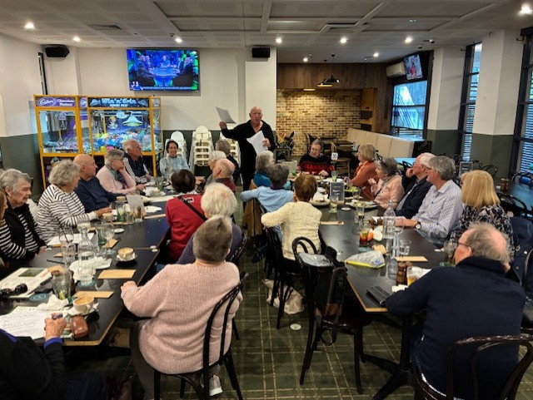
Walking Group

Curl Curl Sports Centre

Monday, September 7
Walk Details: We will meet at 9:30 for 9:45 at the Curl Curl Sports Centre, Netball Park, Abbott Rd, opposite Playfair Rd and walk along the park, returning to Playfair Rd where we will walk up 200m to Curly’s on the corner to enjoy our traditional coffee.
Walk time: Approximately one hour.
Grade: Easy, mostly on flat ground.
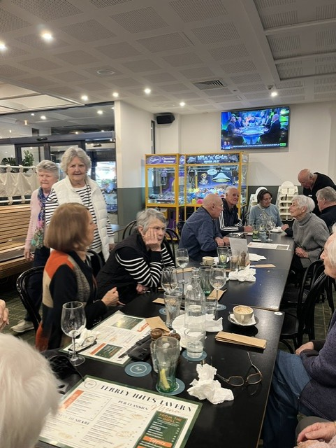
Facilities: There are a number of seats with park views along the way.
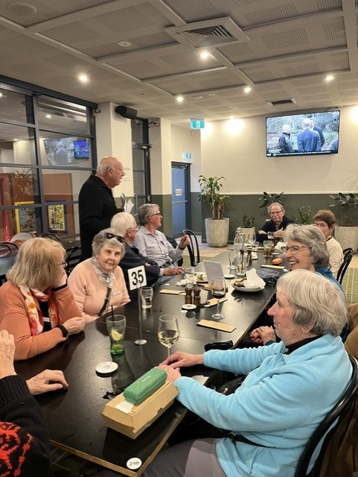
This page and following; Our Terrey Hills Tavern diners.

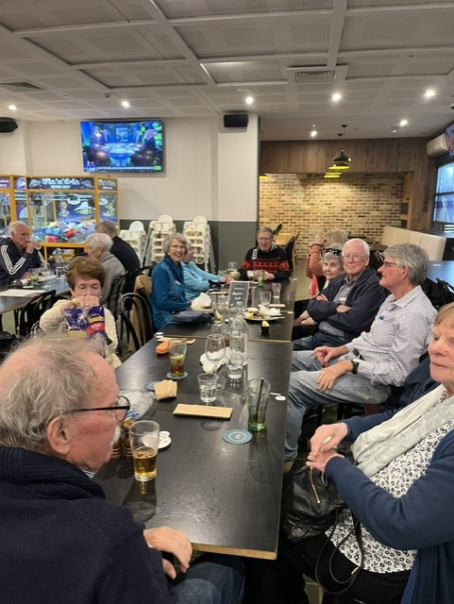

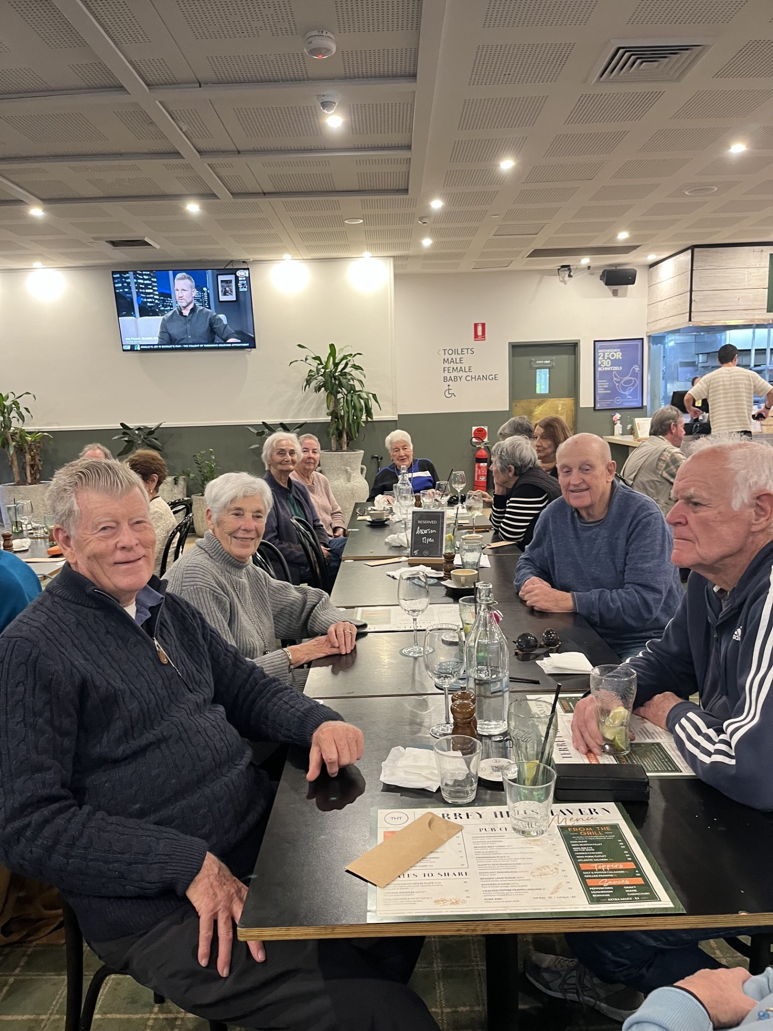
Above: A moment of frivolity at the Terrey Hills Tavern — Clive filches Annette’s cap.

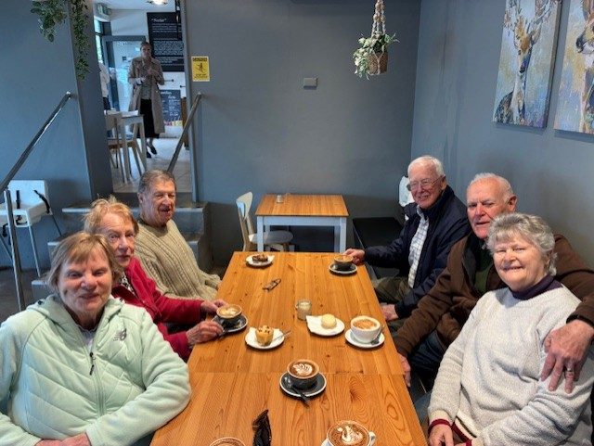

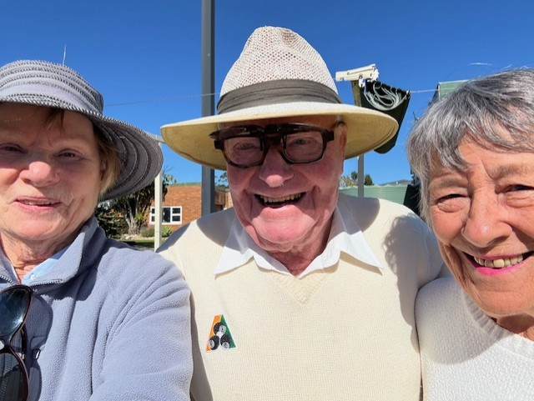
… and the winner was … Nola!!
The August walkers relaxing at Black Nectar Coffee.

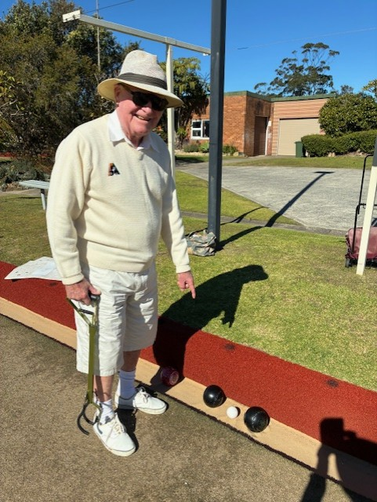
He still has it!!

Probus Club of Seaforth — Founded in 1990, Inc 1996 PO Box 339, Seaforth, 2092 https://SeaforthProbus.Wordpress.com
President: Anne Creek 0422 227 499 douglas.creek@optusnet.com.au; Vice-President: vacant; Secretary: Anne<e Kearns 0417 412 447
amtk1944@hotmail.com; Treasurer: Michael Calloway 0403 207 321 angle_street@optusnet.com.au; Editor and distributor: Ray Isaacs 0478 577 009 ray.n.net@hotmail.com; Getaways Coordinator/$2.50 Opal Days: Barbata Brown 0408 422 514; Guest Speaker Coordinators: Dianne Swan 0409 837 753 dingary44@gmail.com; Susan Stead 0403 219 849 sstead9@tpg.com.au; AEendance Registrar: Peta Cass 0419 442 198 petahcass@gmail.com;
Welfare Coordinator: Judith Doig 9949 2071 pdoi5805@bigpond.net.au; Bowls Coordinator: Hazel Sellin 0422 524 021 hazelsellin@bigpond.com;
Culture Coordinator: vacant; Walking Group Coordinators: Ray Isaacs 0478 577 009 ray.n.net@hotmail.com; Hazel Sellin 0422 524 021
hazelsellin@bigpond.com; Luncheon Group Coordinators: Hazel Sellin 0422 524 021 hazelsellin@bigpond.com; Carmen Anderson 0422 412 184 carmen.anderson7@icloud.com; Technology Group/Club Historian/Registrar: Gavin Kerr, 0404 073 760 ghmkerr@icloud.com; RecruiOng: Lili Koch 0417 691 779 lilikoch@bigpond.net.au.

