
President’s Message
The Probus Club of Seaforth

N E W S L E T T E R
September 2026
Volume 36 Issue 7
Published monthly Private and confidential For Probus use only —
not to be used for any other purpose

September Meeting
Tuesday 22nd Seaforth Bowling Club
Meeting Agenda
9.30 Registration, morning tea and fellowship.
10.00 Guest Speaker: Eira Bish-Bataglia — Wild Life Rescuer.
10.50 Business.
If not attending, please inform: Peta Cass, petahcass@gmail.com.
October meeting: Tuesday 27th

September 2026
Once again I am always impressed by the work done by the wonderful volunteers in our community. Our recent speakers showed their enthusiasm and knowledge of a beautiful area at North Head. it is important that we support these people by visiting, doing a walk or listening to the varied talks available. It is a great place for a picnic or drinks in the late afternoon.
We're looking forward to hearing from our new Events Organiser. Thank you Barbara for taking on this role. Let's try and support Barbara when possible.
We will have to make a firm decision as to where our Christmas Lunch will be held this year. The recent Christmas lunch (at the club) was a great success but we must remember that the room has to be set up, cleaned up and tables replaced. This was done by only a few people.
The alternative is to select a venue where everything is organised and everyone can relax.
I hope everyone is enjoying our early spring and the glorious wattle and flowers that are blooming everywhere..
I'm looking forward to greeting any visitors and new members at our meeting.

Anne Creek
Coming Events, Registrations and Payments 2026
Oct 21 (Wed) — $2.50 Opal Day — Harris Park, Little India. Dec 7 (Mon) Xmas Luncheon — details to follow.
Credit card, cash or cheque payable to the Probus Club of Seaforth Inc Seaforth Banking information: BSB — 032 294; Account No. — 690735
Current Membership 67
September BIRTHDAYS
Pam Ockerby 4; Susan Goldberg 19 September.

Guest Speaker
Eira Bish-Bataglia — Wild Life Rescuer
The speaker for September is Eira Bish-Bataglia who works as a volunteer Wild Life Rescuer and Carer. She aims to rescue and care for sick, injured, and orphaned native wildlife and to safely release them back into the wild.
Susan Stead and Dianne Swan

Welfare Report
I hope all Probus fathers had a great day with their families on Fathers Day. Ella Doutreband has been in hospital for the last few weeks, hopes to get home this week. Mary Bacon who moved to Perth to with her niece and family has sadly passed away. Mary held a number of admin: positions in the sporting world. If you know of anyone who is not feeling well, please do not hesitate to let me know.

Judith Doig
Activities
Save the Day …
MONTHLY LUNCHEON/TRIVIA
Balgowlah RSL, Ethel St, Seaforth 12 noon, Tuesday,October 6
Names to Carmen Anderson — 0422 412184, email carmen.anderson7@icloud.com
Carmen Anderson/Hazel Sellin — Luncheon Coordinators

Bowls Report
A few ‘old faithfuls’ have been getting a good dose of sunshine, exercise, fresh air and laughs of recent weeks. We have not disintegrated yet.
Warren kept threatening to go home this morning so he could read his Spike Milligan book but we managed to keep him there swinging his arm for an hour.

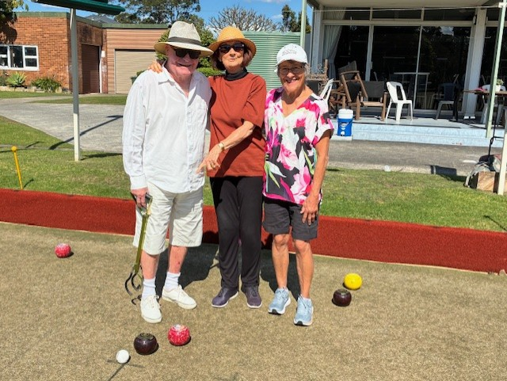
Three winners.

We all send our very best wishes to John Grant who is having a spell in hospital. Hope you are back home very soon, John.
The pooey, vile, putrid smell coming from the lagoon waters took some of the gloss off our excursion but somehow we managed to soldier on.
Ray and Jeannette did join the four of us at Curlys for a very much enjoyed coffee and chat after the walk.

Hazel Sellin
PS, an article in the Manly Observer, forwarded by Judith, confirmed the sewage pollution in the lagoon.

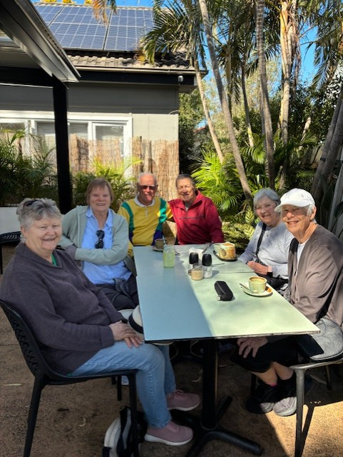
Hazel Sellin, Bowls Co-ordinator

Walking Group

Dee Why Beach to Fisher Road Nth

Monday, October 12
Walk Details: We will meet at 9:30 for 9:45 at Dee Why Surf Club car park at Dee Why Beach. This is a lovely leisure walk past many parks and playing fields and will be followed by a social time over coffee at Dee Why Beach. Distance 5 km.
Walk time: Approximately 60 minutes return.
Grade: Easy.
Facilities: Toilets and bubblers at Dee Why Beach.
Enquiries: Ray Isaacs, 0478 577 009; Hazel Sellin,
0422 524 021.

Curl Curl Lagoon walk, Monday, Sept 7
Well, all I can say is that Ray Isaacs, our leader, must have had a premonition and very conveniently forgot about the walk and did a “no show”. All despite his previous undertaking to walk us all ‘off into the bushes’.
This left Judith Carpenter, Dianne and Gary Swan and

Our September walkers Dianne, Hazel, Gary and Judith, with two “sometimes” walkers, Ray and Jeannette.

Tech Group
The next Tech Group meeting will be at the Seaforth Bowling Club at 11 am October 13.
Members, interested in learning the ins and outs of their mobile phones, iPads and/or laptops, the vagaries of the Internet, spam and AI, etc, are more than welcome. It’s not all serious — plenty of laughs ensured.
If you would like to join our Tech Group, contact Gavin Kerr at ghmkerr@icloud.com or phone 0404 073 760.

myself to fend for ourselves.
$2.50 Opal Discovery Day

Harris Park — Little India

Wednesday, October 21
Harris Park is informally known as Little India. On the doorstep of the railway station and Wigram St is a cultural precinct which features over 50 authentic restaurants,
sweet shops, Indian grocery stores and Indian ladies clothing.
We will have lunch at Asees Indian Restaurant, 97 Wigram Street. The food is North Indian and Punjab. Great menu and Google 2282 reviews 4.8. It is a busy restaurant and we need to book our group numbers.

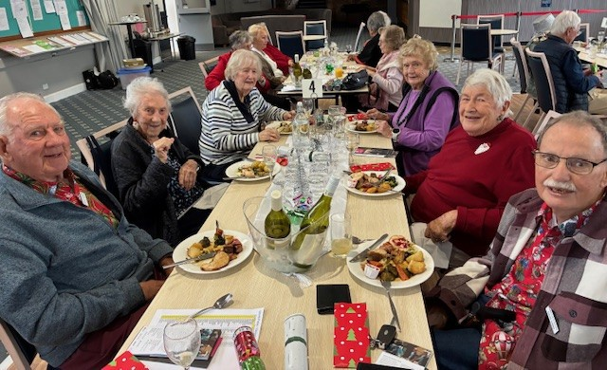
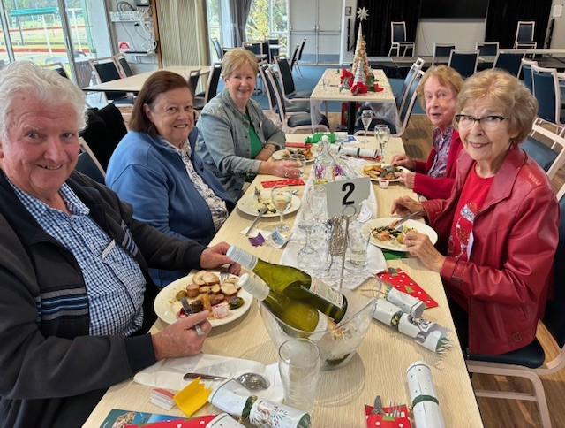
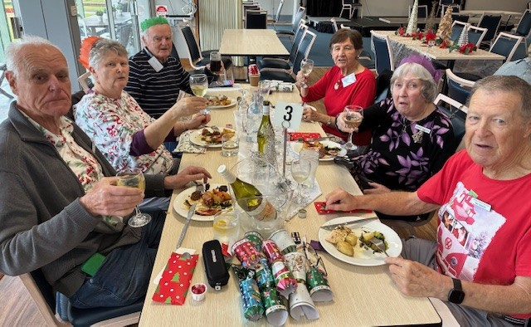
Travel arrangements
For those coming from Manly we will meet at Manly Wharf for the 10am ferry.
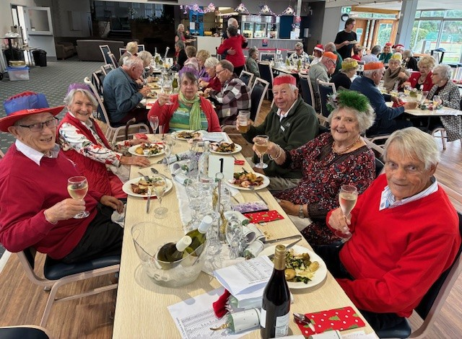
Our group will meet up at Wynyard Station on Platform 3 at the rear steps by 10.50 am. The T1 train departs 11.03 am for Harris Park and to arrive 11.26 am
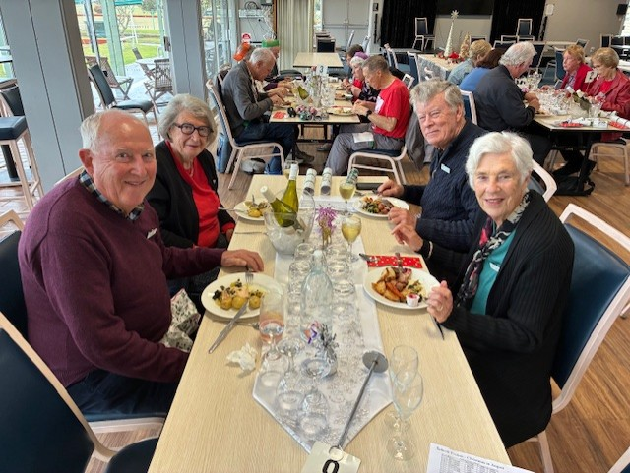
Please register with Lorraine Sergent 0410 184 895 or lsergent44@gmail.com.
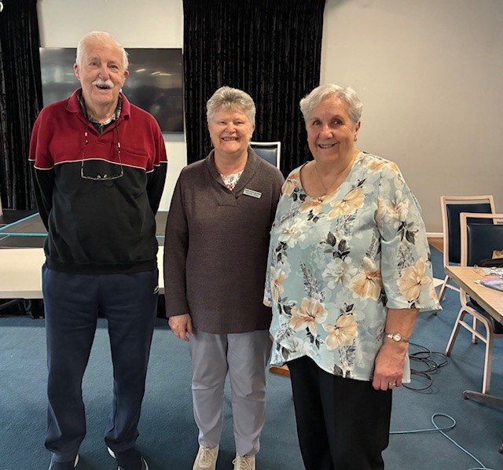
Our August guest speakers Mary Palmer and husband; and following: Xmas in August.

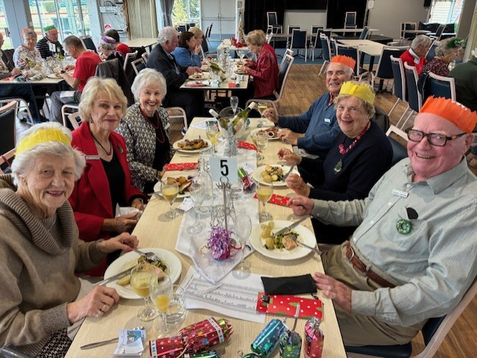
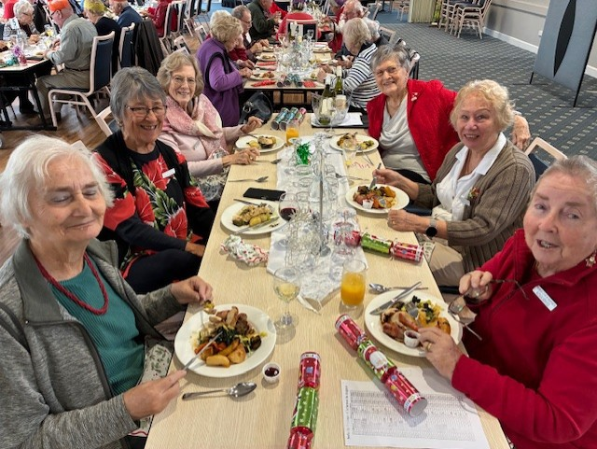
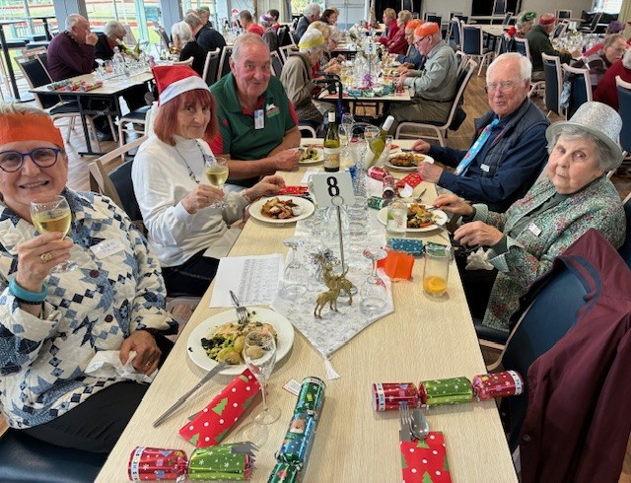
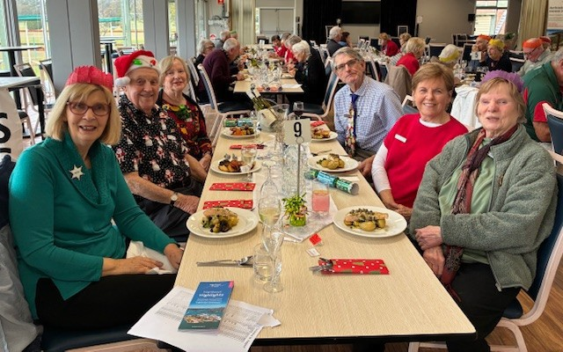

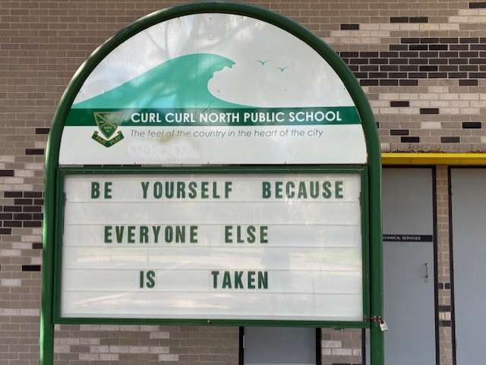
Amen.

Probus Club of Seaforth — Founded in 1990, Inc 1996 PO Box 339, Seaforth, 2092 https://SeaforthProbus.Wordpress.com
President: Anne Creek 0422 227 499 douglas.creek@optusnet.com.au; Vice-President: vacant; Secretary: Anne<e Kearns 0417 412 447
amtk1944@hotmail.com; Treasurer: Michael Calloway 0403 207 321 angle_street@optusnet.com.au; Editor and distributor: Ray Isaacs 0478 577 009
ray.n.net@hotmail.com; Getaways Coordinator: Barbara Brown 0408 422 514 Hi_Barb@hotmail.com; $2.50 Opal Days: Lorraine Sergent 0410 184
895 lsergent44@gmail.com; Guest Speaker Coordinators: Dianne Swan 0409 837 753 dingary44@gmail.com; Susan Stead 0403 219 849
sstead9@tpg.com.au; ADendance Registrar: Peta Cass 0419 442 198 petahcass@gmail.com; Welfare Coordinator: Judith Doig 9949 2071 pdoi5805@bigpond.net.au; Bowls Coordinator: Hazel Sellin 0422 524 021 hazelsellin@bigpond.com; Culture Coordinator: vacant; Walking Group Coordinators: Ray Isaacs 0478 577 009 ray.n.net@hotmail.com; Hazel Sellin 0422 524 021 hazelsellin@bigpond.com; Luncheon Group Coordinators:
Hazel Sellin 0422 524 021 hazelsellin@bigpond.com; Carmen Anderson 0422 412 184 carmen.anderson7@icloud.com; Technology Group/Club
Historian/Registrar: Gavin Kerr, 0404 073 760 ghmkerr@icloud.com; RecruiOng: Lili Koch 0417 691 779 lilikoch@bigpond.net.au.

Probus Club of Seaforth

MINUTES OF GENERAL MEETING
Tuesday, 25th August, 2026, Seaforth Bowling Club
President Anne Creek opened the meeting at 10 am, welcoming members and guests.
GUEST SPEAKER: Dianne Swan introduced Marie Palmer and her husband who both volunteer with the Sydney Harbour Trust. Their presentation covered North Head Sanctuary, Manly.
ATTENDANCE: Present 48, Apologies 6, no visitors.
MINUTES OF PREVIOUS MEETING: Moved Clive Sergent, seconded Colin Carpenter that the July minutes be accepted. Carried.
BUSINESS ARISING: There were seven apologies for July meeting and not one. (Anderson, Kearns, Barb Brown, Smart, Reese and Sellin were away on Bathurst trip).
Sheila Taylor and Margaret Emanuel to be inducted at September meeting.
BIRTHDAYS: Andy Lynch, Pat Cooper and Barb Brown.
WELFARE: Judith Doig wished members good health, before explaining to members the drink voucher for today’s Xmas in August Luncheon was for beer or soft and did not cover spirits.
TREASURER'S REPORT: While Michael Calloway left to be granted Life Membership at Balgowlah Bowling Club, Carmen Anderson presented his report on his behalf. Closing balance as at 24/8/2026 was $10,099.21. Report moved by Margaret Greig and seconded by Grahame Goldberg.
OPAL DAY: On Thursday 20th August, 13 members thoroughly enjoyed a tour of the Children’s Medical Research Centre at Westmead Hospital. Jennifer Philps who was our Guest Speaker a few months ago, was in charge of proceedings.
Our next Opal Day will be on Wednesday, 21st October, 2026 at Harris Park for Indian lunch.
TRIPS: Barb Brown has offered to take over extended tours from Clive Sergent. Thank you Clive for all your good work.
LUNCHEON/TRIVIA: Monday, 14th September, 2026 at Forest Hotel
WALKING GROUP: Monday, 7th September, 2026, meet at 9.30 am for 9.45 am take off at Netball Courts in Abbott Road (opposite Playfair Road), Curl Curl. Walk 200 meters to Curlys for coffee and laughs after walk.
BOWLS: Bowls cancelled Thursday 20th due to Opal Day Tour being changed. We resume Thursday 27th, weather permitting.
TECH GROUP: Next meeting 11 am, Tuesday 8th September, 2026 at Seaforth Bowling Club. Note — change of venue from Totem Club.
GENERAL: Suggestions for a Xmas venue welcome.
Clive suggested we subsidise our Christmas party by $25-$30 from our built up funds.
Harbour Trust volunteers are unable to accept gifts so Dianne Swan has been asked if a donation direct to Sydney Harbour Trust is permissible.
Thanks to Michael Calloway and Judith Doig in organising today’s Christmas in August. Once again President Anne appealed for a Vice President.
WINE RAFFLE: Helen Pajak and Doug Creek.
NEXT MEETING: Tuesday, 22nd September, 2026.
There being no further business, the meeting closed at 11.40 am. PRESIDENT:..................................................................SECRETARY: .................................................................. DATE: ...........................................................................

